 |  |  |  | PARTICIPANTS

Jasmin Alsaied

Nuclear Scholar
Lieutenant Jasmin Alsaied graduated from North Carolina State University with a Bachelor of Science in Nuclear Engineering and a minor in mathematics. She earned her commission through the NROTC program and was subsequently stationed onboard USS LASSEN (DDG 82). During her four years attached to USS LASSEN, she completed a Middle East deployment with the TRUMAN Strike Group, participated in the maiden voyage for HMS Queen Elizabeth, GERALD R. FORD shock trials, and engaged in Caribbean counter-narcotic operations. Jasmin is currently pursuing a Master of Science in Foreign Service (MSFS) at Georgetown University with a focus in Global Politics and Security and Diplomatic Studies. Her current research interests are counterproliferation challenges and security issues in the Indo-Pacific. Jasmin has recently worked on Capitol Hill, with the Institute for the Study of War, and at H+K Strategies. She is a Nuclear Scholar at CSIS. She speaks Arabic and English.
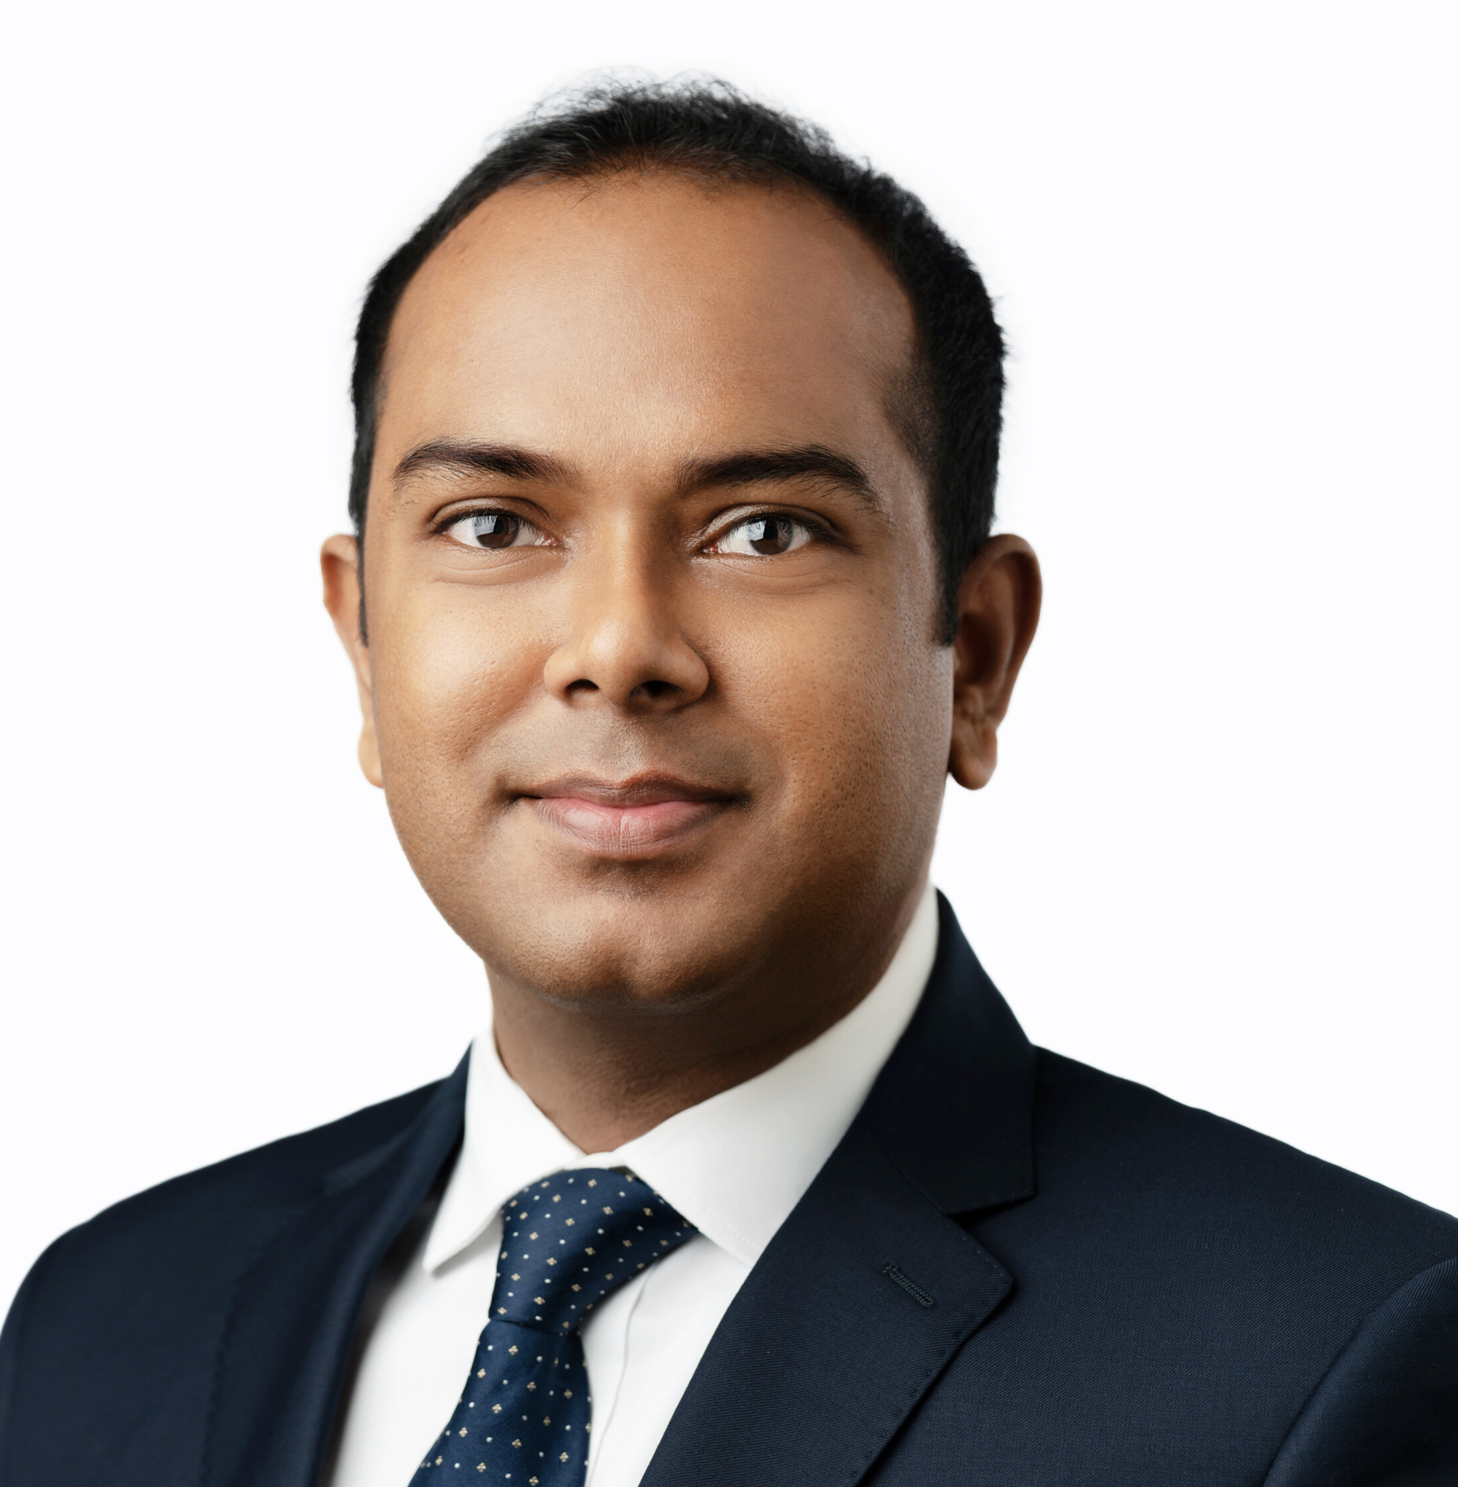 |  |  |  | Anu Anwar  Fellow  Anu Anwar is a fellow at the Faculty of Arts and Sciences and an associate in research at the John K. Fairbank Center for Chinese Studies at Harvard University. Before joining Harvard, Anwar worked as a research fellow at the U.S. Department of Defense Daniel K. Inouye Asia-Pacific Center for Security Studies. Anwar was educated at Tsinghua University, the University of Geneva, the University of Dhaka, and is currently pursuing a Ph.D. in international relations at the Johns Hopkins School of Advanced International Studies. He has traveled around 50 countries and has extensive experience living and traveling in China. He speaks Chinese, Hindi, and Bengali.
 |  |  |  | Ava Benkhatar  Program Manager  Ava Benkhatar is program manager for the Nuclear Science and Security Consortium. As program manager, Ava's main initiative is to facilitate consortium engagement through strengthening the partnerships between universities and national laboratories. She implements consortium programming through: planning and facilitating academic conferences, webinars, and summer schools; tracking and creating database metrics; and functioning as the central point of contact for all program communications. Ava graduated from the University of Central Florida where she received a bachelor’s degree in Political Science, and two certificates in “Intelligence and National Security” and “Diplomacy.” Before starting her position at UC Berkeley, Ava was an intern at Lawrence Livermore National Laboratory. While at LLNL, she researched x-ray irradiator alternatives to Cs-137 and Co-60 sources for the Global Security directorate. She also created data management systems and an internal website for the Supply Chain and Management department.
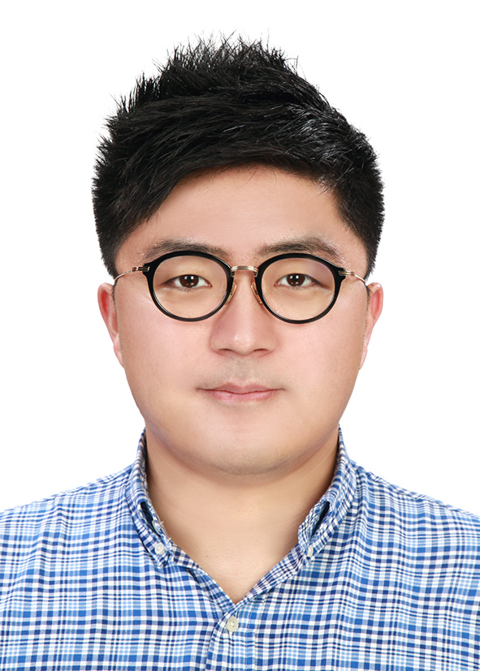 |  |  |  | Yu Bin Kim  Ph.D. Candidate  Yu Bin Kim is currently a Ph.D. candidate in political science at the Harry S Truman School of Government & Public Affairs at the University of Missouri. He is also a Graduate Fellow at the MU Institute for Korean Studies. His research interests include both interstate and intrastate conflicts. At the interstate level, he focuses on nuclear proliferation and on nuclear latency. At the intrastate level, his focus is on conflict management and on UN peacekeeping operations; he is interested in rebel group dynamics, particularly rebel governance and diplomacy, as well. Kim holds a M.A. in East Asian Studies from Stanford University and a B.A. in Asian Studies, International Studies, and Political Science from the University of Wisconsin-Madison.
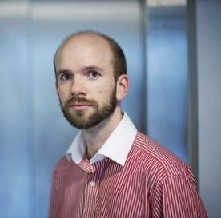 |  |  |  | Niklas Brännström  Deputy Head  Niklas Brännström works for the Swedish Defence Research Agency, FOI, where he is the deputy head of the division of CBRN Defence and Security. The division is a research division that monitors and analyses the current CBRN-threat, strengthens protection against CBRN-incidents and enhances nonproliferation work. He joined FOI about 10 years ago as an atmospheric dispersion modeller, and later lead that research group before becoming head of department for threat analysis (CB), radioactive substances and dispersion modelling. He received his Ph.D. in mathematics from the University of Warwick, UK.
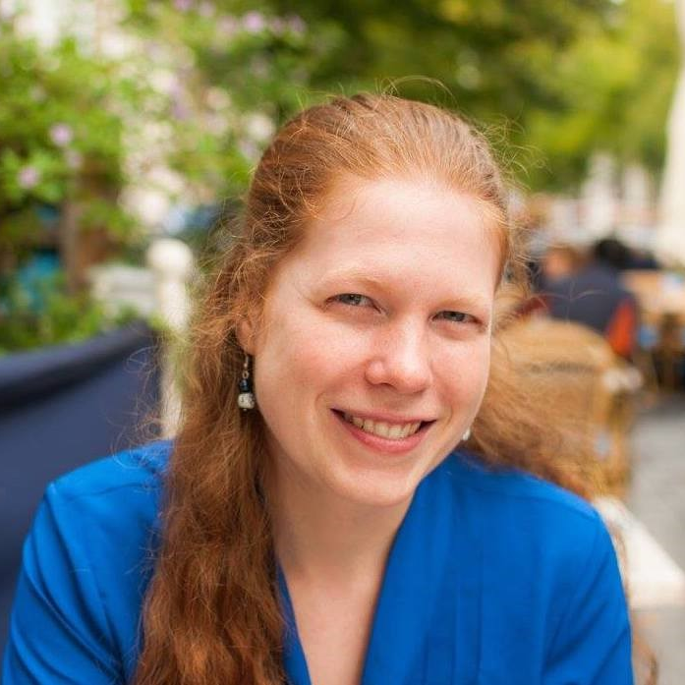 |  |  |  | Mary Burkey  Staff Scientist  Mary Burkey is staff scientist at Lawrence Livermore National Laboratory working in national security applications after recently transitioning from postdoc position in the Planetary Defense Group. Before coming to LLNL, she was a Mirzayan Fellow at the National Academies of Sciences for the Committee on International Security and Arms Control. She earned her Ph.D. in Physics at the University of Chicago and Argonne National Laboratory and her bachelors’ degrees at North Carolina State University.
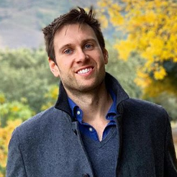 |  |  |  | Justin Key Canfil  Postdoctoral Fellow  Justin Key Canfil is a postdoctoral fellow with the Harvard Belfer Center's International Security Program. His research examines the legal and security implications of emerging technologies. He is especially interested in past and present efforts to future-proof arms control regimes. His book project asks why some militarily impactful technologies are considered more legally problematic than others, and explains how states manage these emergent controversies in times of rapid change. Justin was previously a postdoctoral fellow with the Columbia-Harvard China and the World Program, a predoctoral fellow with the Harvard Cyber Project and USC's U.S.-Asia Grand Strategy Program, a China Fulbright Scholar, as well as an affiliate of Peking University, Fudan University, Oxford, the Wilson Center, and the London School of Economics. He holds a Ph.D. in Political Science from Columbia University.
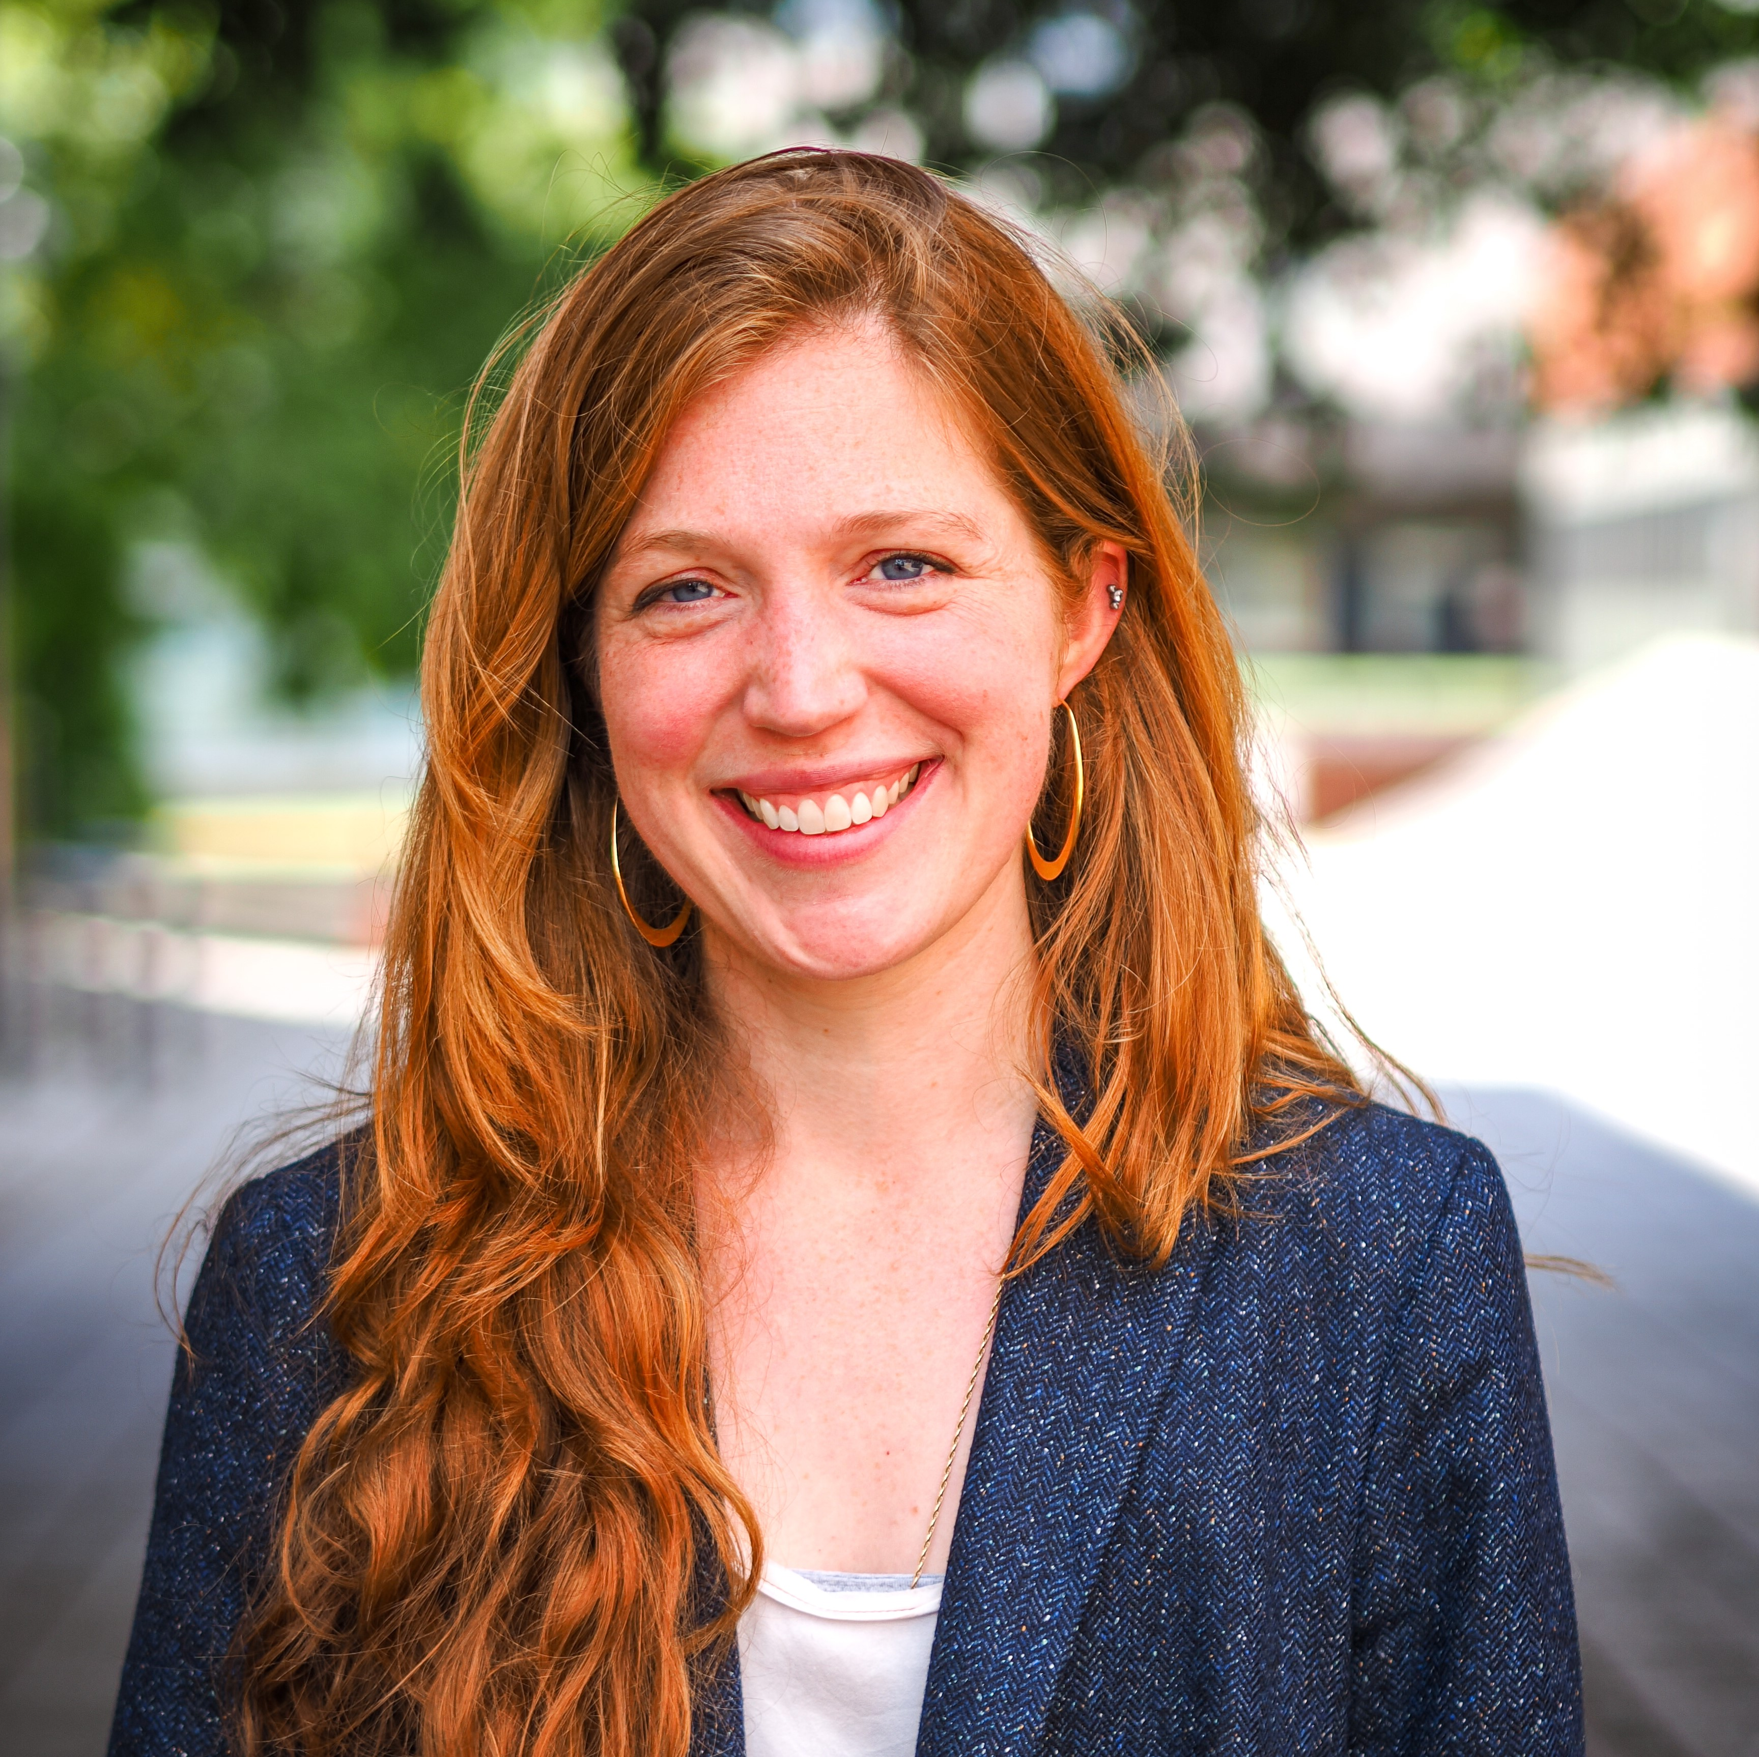 |  |  |  | Jane Darby Menton  Ph.D. Student  Jane Darby Menton is a Ph.D. candidate at Cambridge in the Department of Politics and International Studies. Her research looks at the domestic politics of international diplomacy, focusing in particular on the agreement and unravelling of the JCPOA. Prior to Cambridge, she worked as a journalist at CNN and Foreign Affairs. She has an MPhil in Modern Middle Eastern Studies from Oxford and a B.A. from Yale.
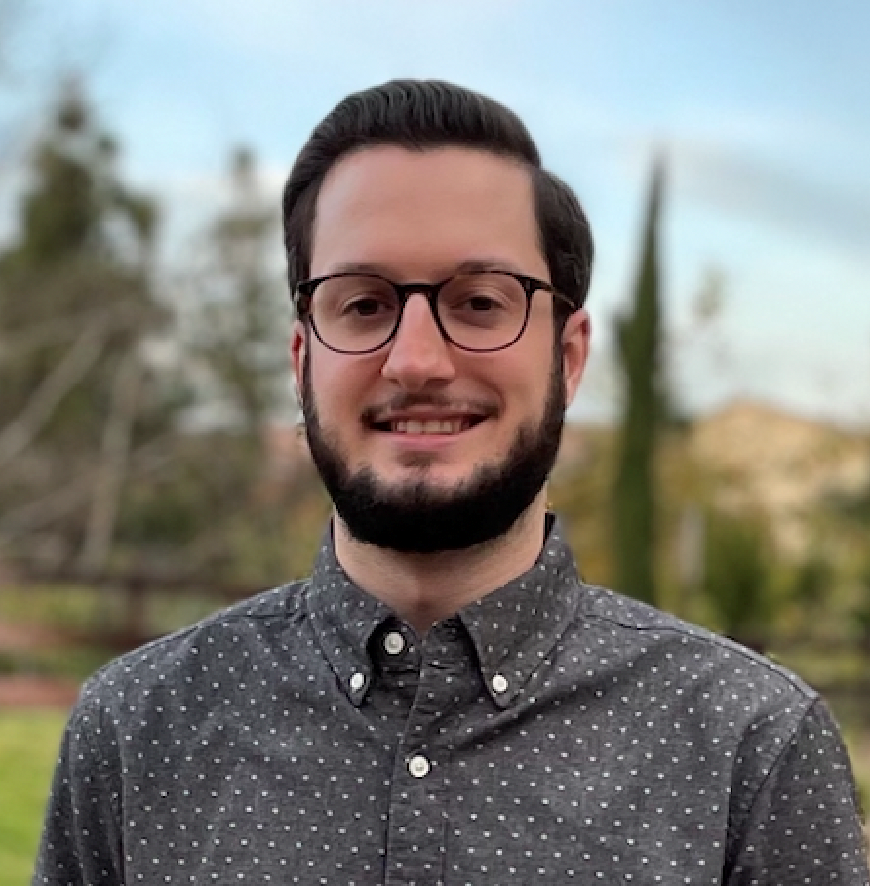 |  |  |  | John Thomas Deacon  Ph.D. Student  John Thomas Deacon is a political science Ph.D. student advised by Dr. Etel Solingen at UC Irvine studying Chinese foreign policy and the politics of nuclear weapons. His research seeks to understand the motivations and aims underlying China’s efforts to expand and modernize its nuclear arsenal, as well as the implications for nuclear proliferation in East Asia. He plans to develop expertise on Chinese nuclear weapons policy and pursue a career as an academic researcher.
 |  |  |  | Nour Eid  Master’s Student  Nour Eid is an International Security master’s student at Sciences Po in Paris. Her concentrations are on Middle Eastern Studies and Intelligence. Prior to her master’s degree, she completed an internship in the Nuclear Power Engineering Section of the International Atomic Energy Agency (IAEA). She graduated in 2020 with a bachelor’s degree in Political Studies and International Law, from the American University of Beirut (AUB), in Lebanon. Her past work and publications are associated with the development of nuclear capabilities, both from the perspective of energy and the capacity for diversion in the pursuit of nuclear weapons. She therefore developed experience on geopolitical and strategic considerations across the Middle East.
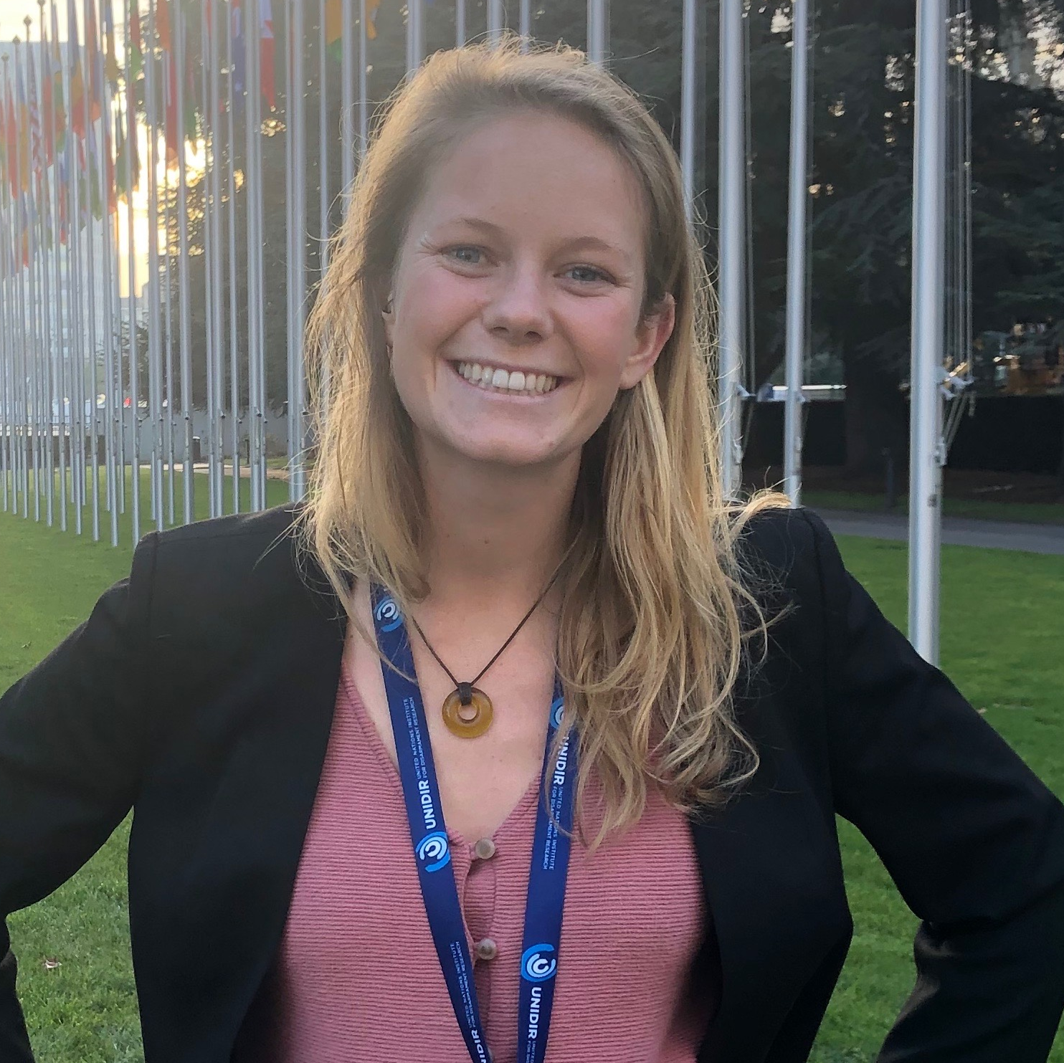 |  | Jennifer Hart  Research Analyst  Jennifer Hart is a Research Analyst at the Pacific Northwest National Laboratory (PNNL) working on a range of projects supporting the National Nuclear Security Administration’s work on International Atomic Energy Agency safeguards policy, safeguards concepts and approaches, Nuclear Suppliers Group industry engagement, and radiological security. Prior to PNNL, Jenn held research positions at the United Nations Institute for Disarmament Research and the Naval Postgraduate School. Jenn holds a Master of Arts in Nonproliferation and Terrorism Studies from the Middlebury Institute of International Studies, where she specialized in financial crime management, and a Bachelor of Science in Psychology from Jacksonville State University. Jenn is also Certified Anti-Money Laundering Specialist.
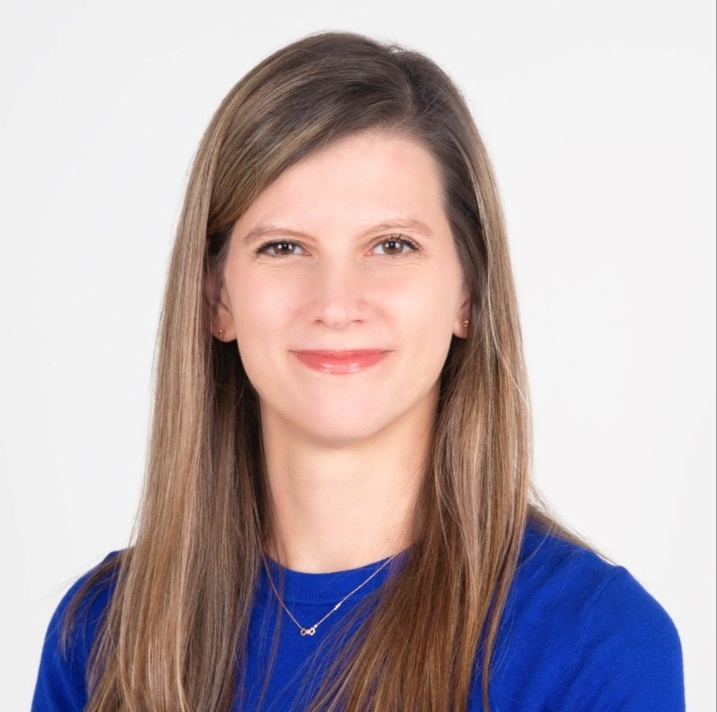 |  | Caroline Kearney  Ph.D. Candidate  Caroline Kearney is beginning the third year of her Ph.D. program in Korean Studies at Yonsei University in Seoul. Her dissertation is focused on North Korean politics and the decision-making process. She is also a contributing analyst for NK Pro. Previously, Caroline was the Program Manager for the Korean Peninsula at the Centre for Peace and Conflict Studies (CPCS) in Cambodia. In this capacity, she hosted CPCS’ partner organizations from the DPRK for bilateral exchanges, co-organized roundtable discussions, and authored analysis for the Institute for Security and Development Policy (ISDP) and Jeju Peace Institute. She is also a member of the National Committee on North Korea (NCNK).
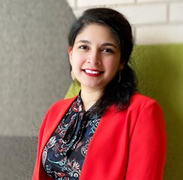 |  | Haneen Khalid  Ph.D. Candidate  Haneen is a policy and research expert focusing on regional and international systems to promote international security. She is a Ph.D. candidate at the Princeton School of Public and International Affairs and Board Fellow at the Bulletin of Atomic Scientists, as well as Board Member at International Student Young Pugwash. She completed her master’s at the University of Chicago as an Obama Foundation Scholar and later the Innovation Fellowship at N-Square. She previously led grassroots and policy initiatives to advance nuclear nonproliferation and arms control in South Asia and the United States. She is connected to the Centre for International Strategic Studies and the Program on Science and Global Security at Princeton, and works on bringing science and diplomacy together for greater security and peace.
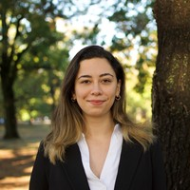 |  | Dilan Ezgi Koc  Nuclear Scholar  Dilan Ezgi Koc has recently completed her master’s studies at Yale University, focusing on nuclear policy, arms control, cybersecurity, and emerging technologies. She is a 2022 Nuclear Scholar at the Project on Nuclear Issues, CSIS, and a UN Youth Champion for Disarmament selected by the UN Office for Disarmament Affairs. During her time at Yale, Dilan worked on the JCPOA as a Kerry Fellow for Secretary John Kerry’s team and conducted research on nuclear strategy, arms control policies and practices, and the impact of emerging technologies on the nonproliferation regime. She will be joining NATO’s Nuclear Policy Directorate in the fall of 2022
 |  | Dylan Land  Master’s Graduate  Dylan Land just completed his Master of Arts in Law and Diplomacy at the Fletcher School, concentrating on International Security and Nuclear Deterrence and Technological Innovation. Dylan’s research revolves around disruptive technologies’ impact on strategic nuclear deterrence, with a focus on multi-domain/integrated deterrence and novel weapons delivery systems. Dylan is particularly interested in exploring if/how the United States can credibly communicate escalation thresholds and buttress strategic deterrence under a national security strategy of multi-domain/integrated deterrence. Dylan is looking forward to creating connections with fellow participants at the PPNT bootcamp that extend beyond this course and into future professional careers. When Dylan is not studying nuclear deterrence, he enjoys watching and playing football, particularly the English Premier League.
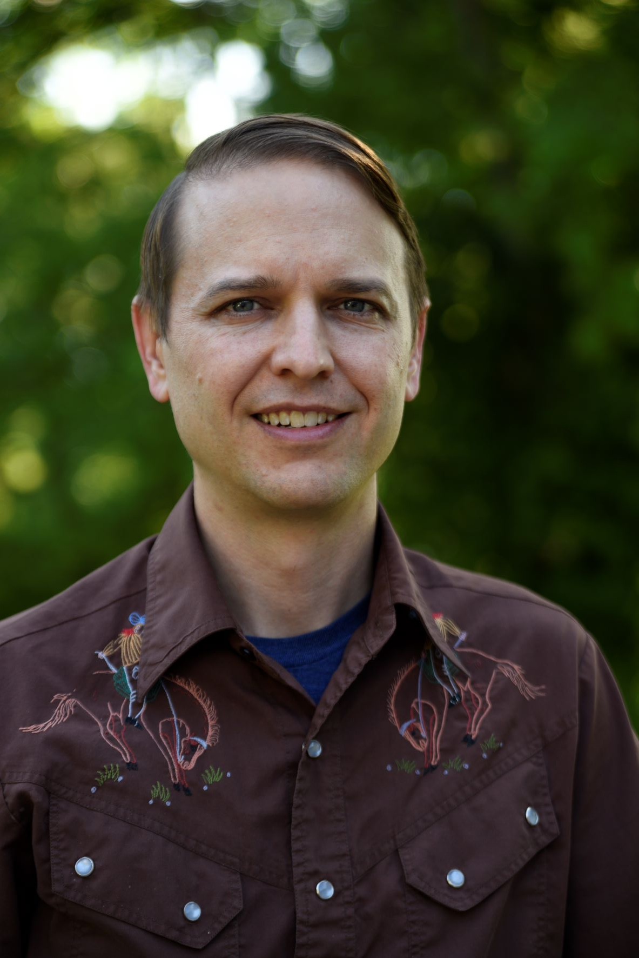 |  | Taylor Loy  Ph.D. Candidate  Taylor Loy brings a diverse academic/professional background to the problems of nonproliferation and disarmament. He worked in operations and training in the nuclear power industry for 6+ years. As a Ph.D. candidate in the Department of Science, Technology, & Society (STS) at Virginia Tech, his dissertation research focuses on the potential for and value of tritium control in nonproliferation regimes. He has presented tritium-related research at the Society for History of Technology (SHOT) 2021 Conference (co-authored with Sonja Schmid) and The Future of Disarmament Workshop in 2021 (University of Glasgow). Currently, he is a member of the Nuclear Futures Working Group (NFWG) with the New America Political Reform program.
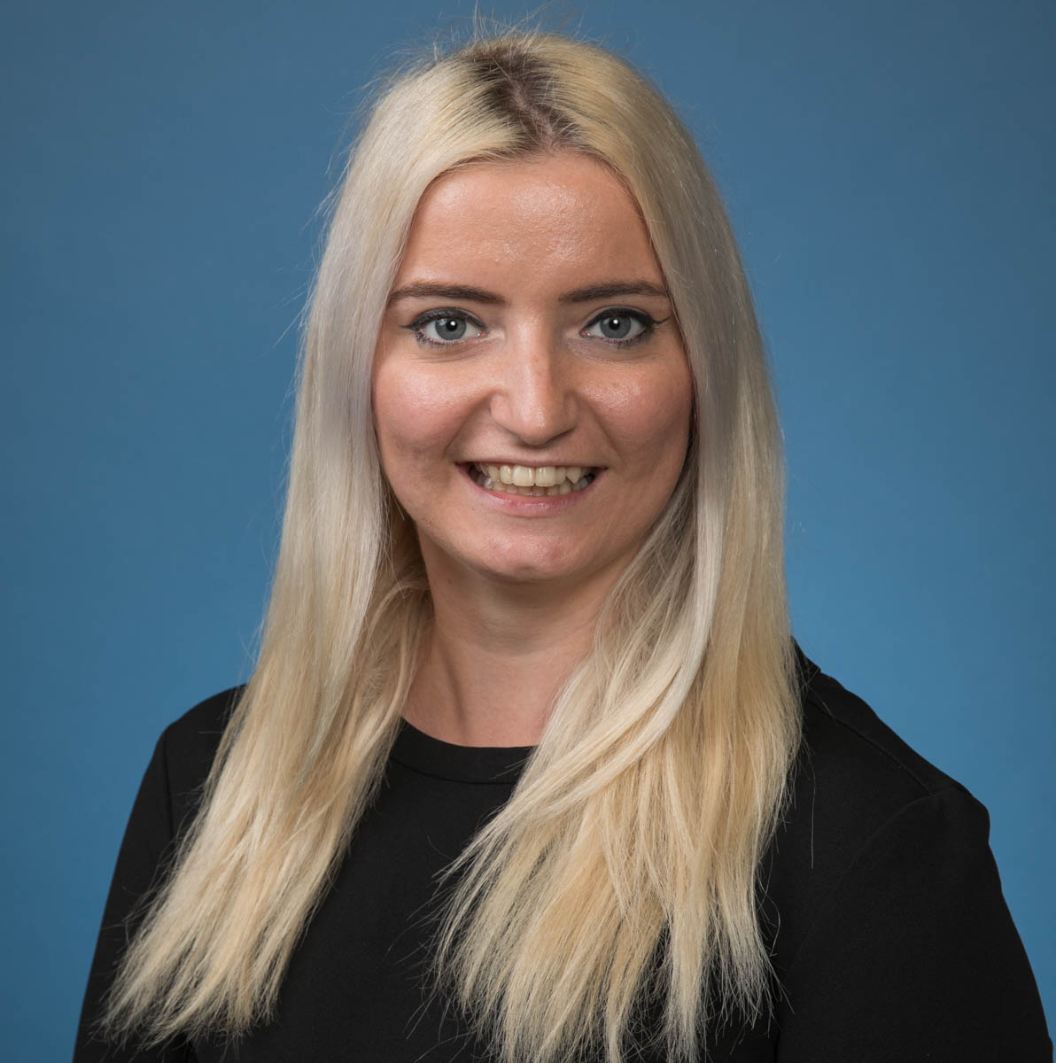 |  | Laura Luca  Ph.D. Candidate  Laura Luca is currently a third year Ph.D. candidate in International Security at UCLA with her research interests covering arms control and nonproliferation, emerging technologies (LAWS) and nuclear weapons policy. Luca has also been practicing IR, covering the Conference on Disarmament and the CCW at the UN in Geneva for two years, and currently working as a diplomat for the European Union. This has influenced her research to be policy-oriented and highly practical in the field.
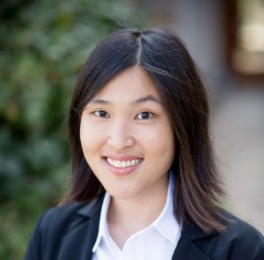 |  | Kimberly Peh Zi En  Ph.D. Candidate  Kimberly Peh Zi En is a Ph.D. candidate in the Political Science Department at the University of Notre Dame. Her research is centered on conflict prevention and de-escalation. Her dissertation looks specifically at explaining and preventing election violence through studying the phenomenon in post-conflict countries. The three-article dissertation will propose a way to measure the levels of election violence; examine the relationship between post-conflict constitutions and election violence; and analyze how political parties affect election violence in post-conflict countries. Prior to joining the University of Notre Dame, she received her B.A. (Hons) in Political Science, which is jointly endorsed by the University of North Carolina – Chapel Hill and the National University of Singapore. Outside of her dissertation, she writes on topics related to nuclear politics; international crises and negotiations; and non-great power foreign policies. She has published in the European Journal of International Security, International Studies Perspectives, and North Korean Review.
 |  | Joel Petersson Ivre  Policy Fellow  Joel Petersson Ivre is a Policy Fellow at the Asia-Pacific Leadership Network for Nuclear Non-Proliferation and Disarmament, located in Seoul. His research interests are in Chinese foreign policy and nuclear proliferation issues surrounding the Korean Peninsula. He received his master’s degree from Yonsei University’s Graduate School of International Studies for East Asian Studies and International Security and Foreign Policy, and his bachelor’s degree in Chinese Language and Culture from Stockholm University.
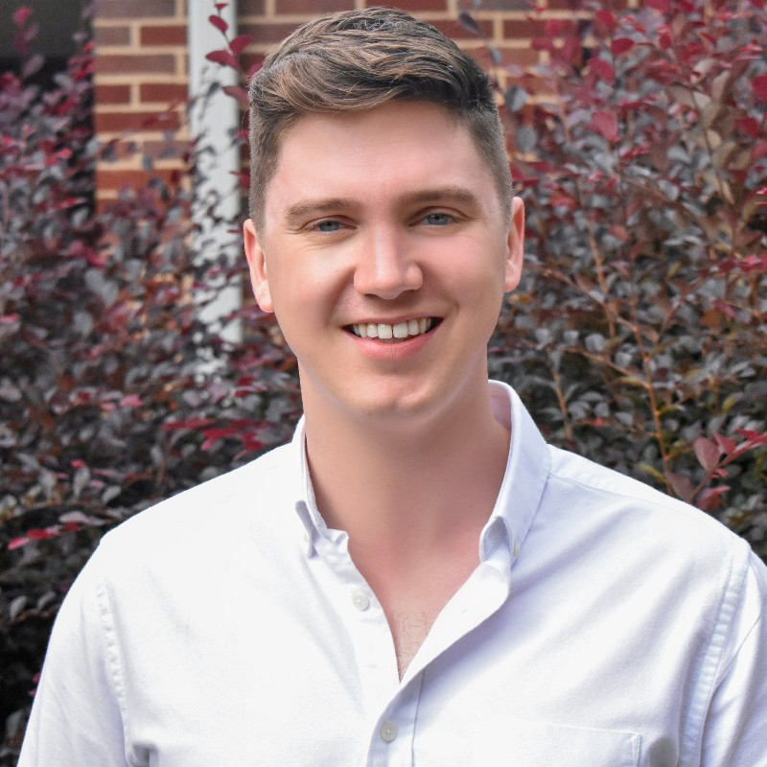 |  | Charlie Prior  Ph.D. Candidate  Charlie Prior is a fourth-year doctoral candidate at Duke University. His research focuses on improving neutrino detectors’ sensitivity. Prior is interested in the applications of neutrino and other nuclear detectors to nuclear safeguards and weapons reductions treaties, and he’s looking forward to learning more about the public policy of nuclear threat reduction. Prior was born and raised in Melbourne, Australia. He studied Maths and Astrophysics for his bachelor’s and master’s degrees at the University of Cambridge, UK.
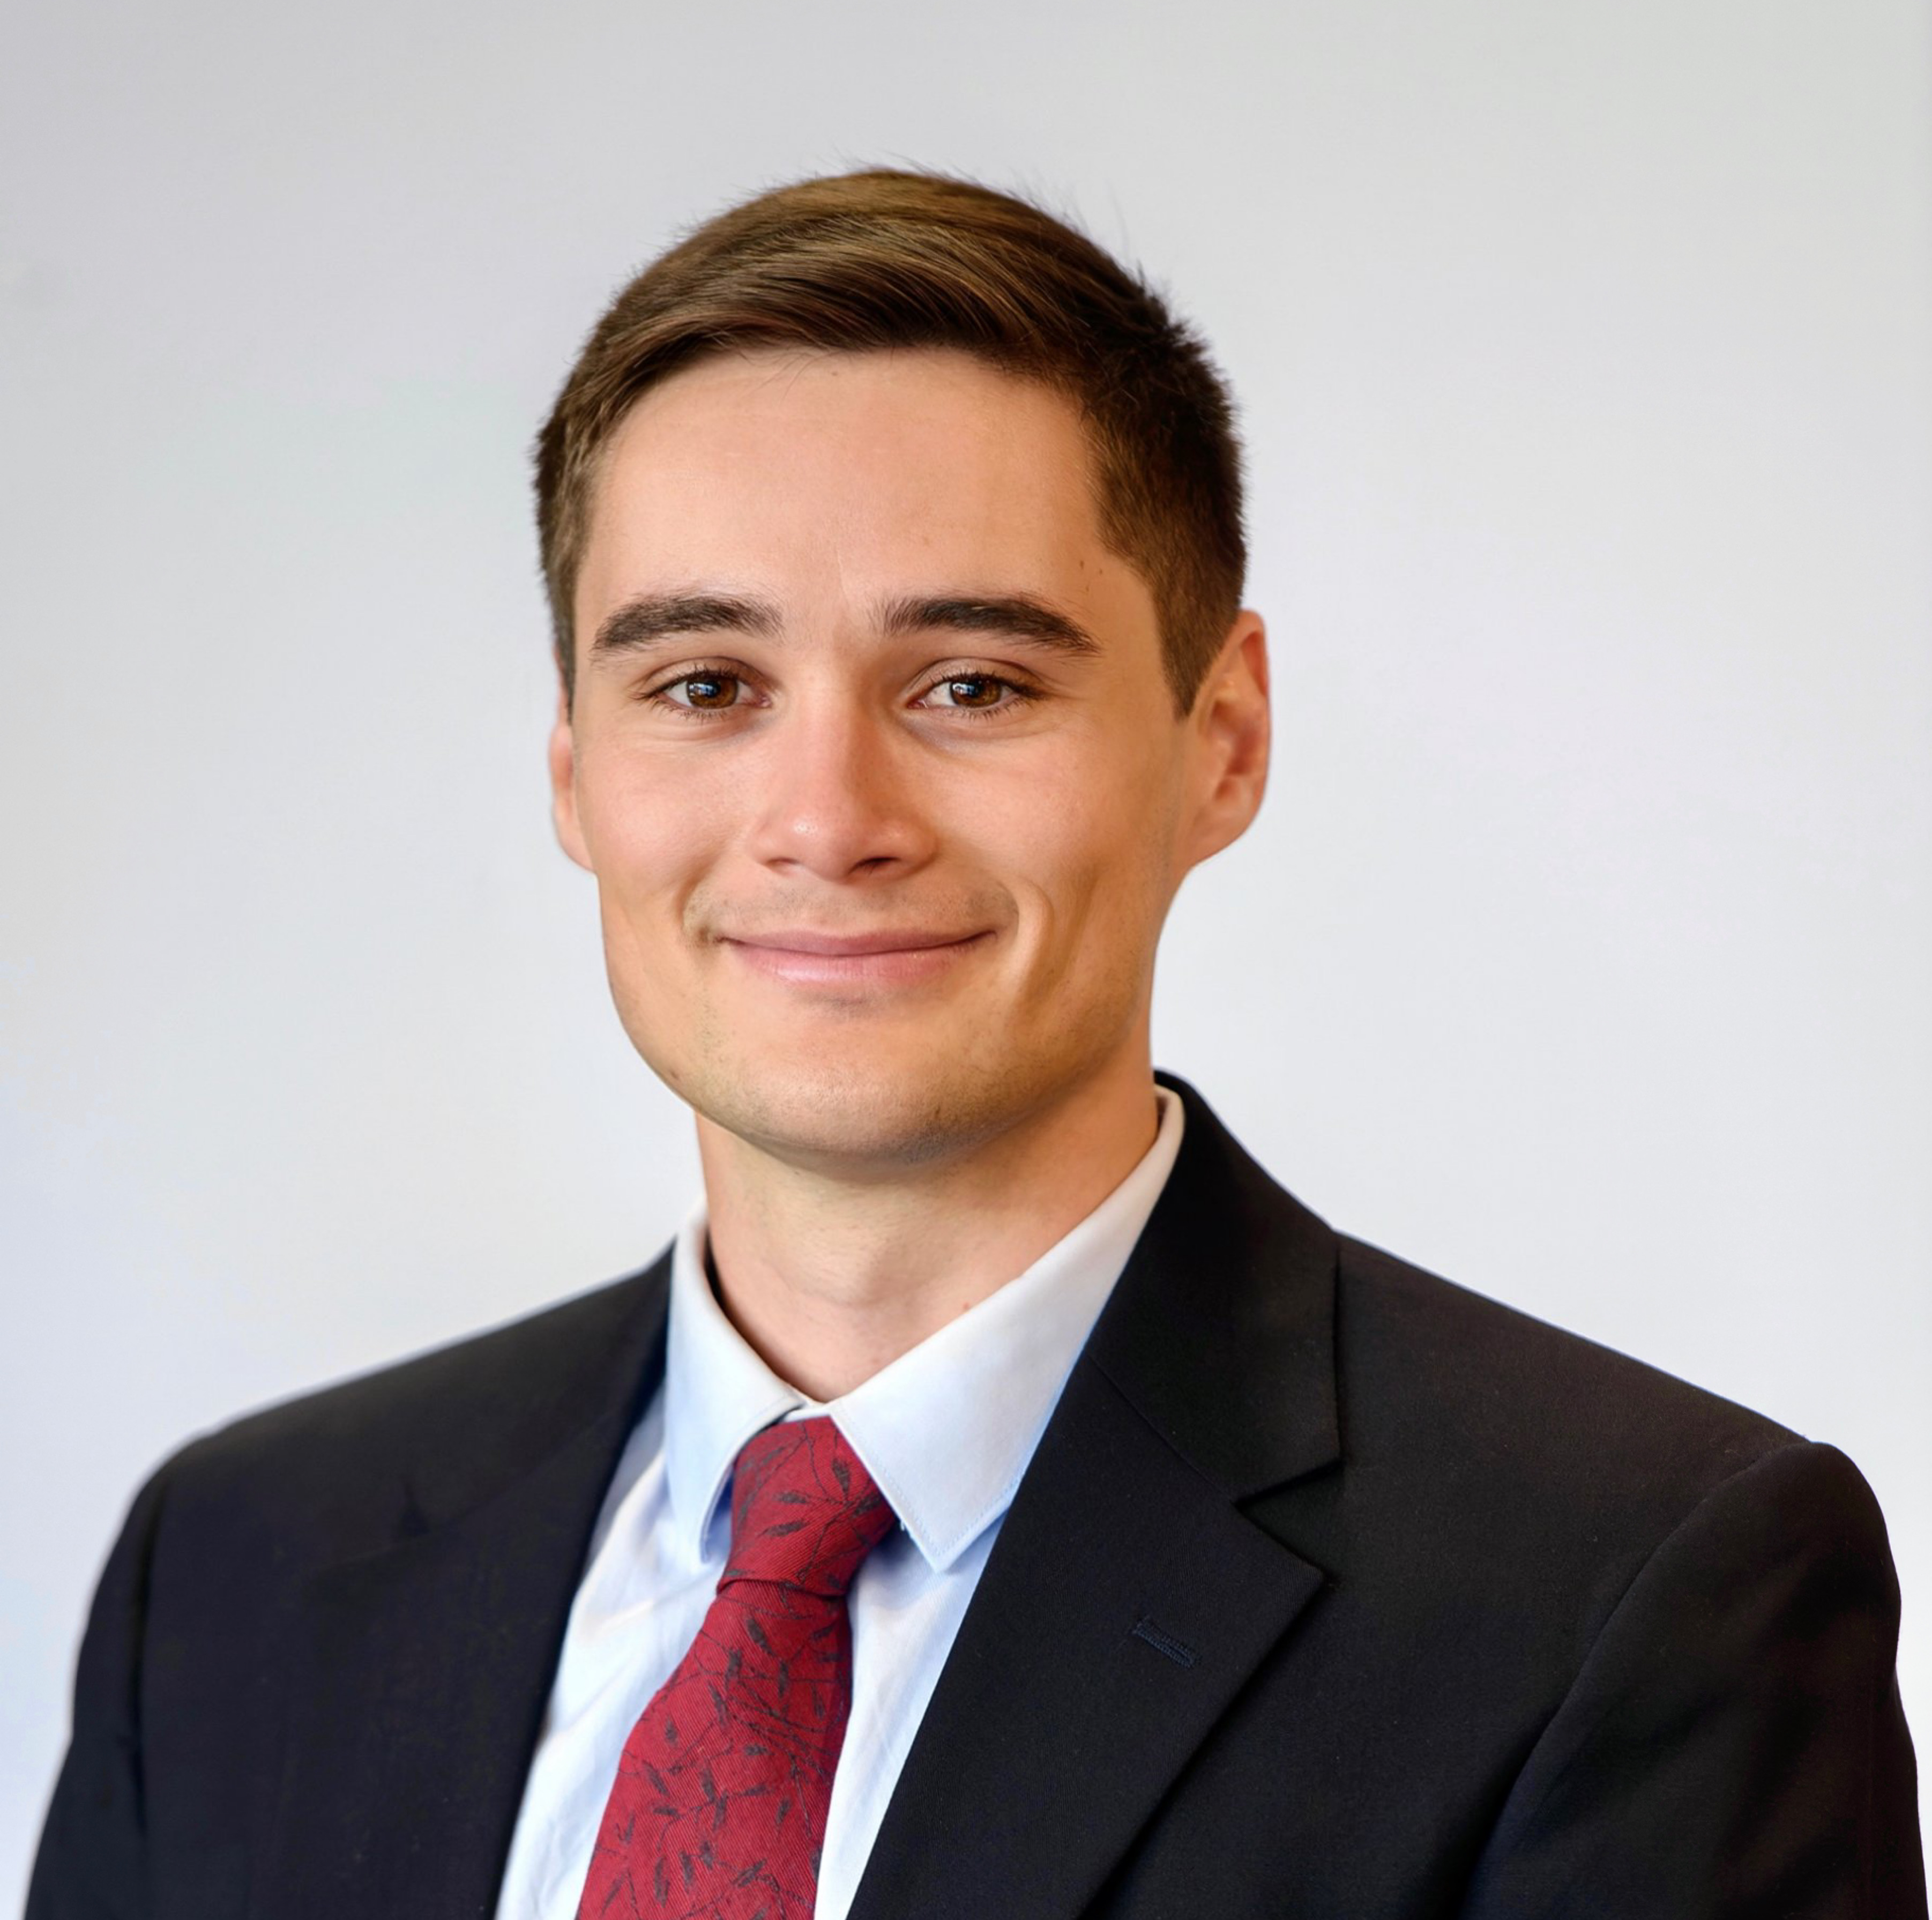 |  | Maclyn Senear  Master’s Student  Maclyn Senear is a second-year Master of Science in Foreign Service candidate at Georgetown University concentrating in Science and Technology in International Affairs. His research interests and professional background center around mitigating the threat of Weapons of Mass Destruction, with particular focus on nuclear nonproliferation, disarmament, biological weapons, and health security. Maclyn has worked for a federal contractor in Alexandria, VA in support of wide-ranging efforts within the Defense Threat Reduction Agency's Research and Development and Cooperative Threat Reduction directorates. Prior to his contractor role, Maclyn also interned at the Arms Control Association in Washington, DC, where he authored or contributed to publications on U.S. missile defense in the Asia-Pacific, the 2018 Nuclear Posture Review, and the status of the Iran nuclear deal, among other topics. Originally from Southern California, Maclyn studied International Relations at Tufts University before moving to the Washington, DC area.
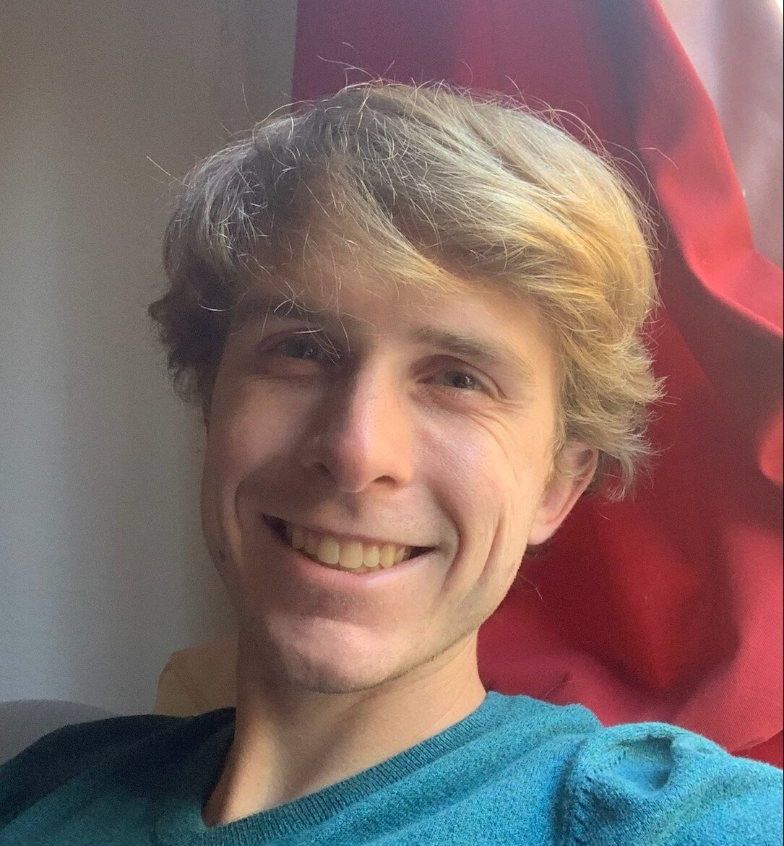 |  | Ryan Smith  Ph.D. Candidate  Ryan Smith is a Ph.D. candidate in physics at UC Berkeley. He studies radiation detection, especially low energy nuclear recoils, using noble liquids. He works on the dark matter direct detection experiments LUX-ZEPLIN and SPICE/HeRALD. Aside from physics, Ryan enjoys competitive long distance running.
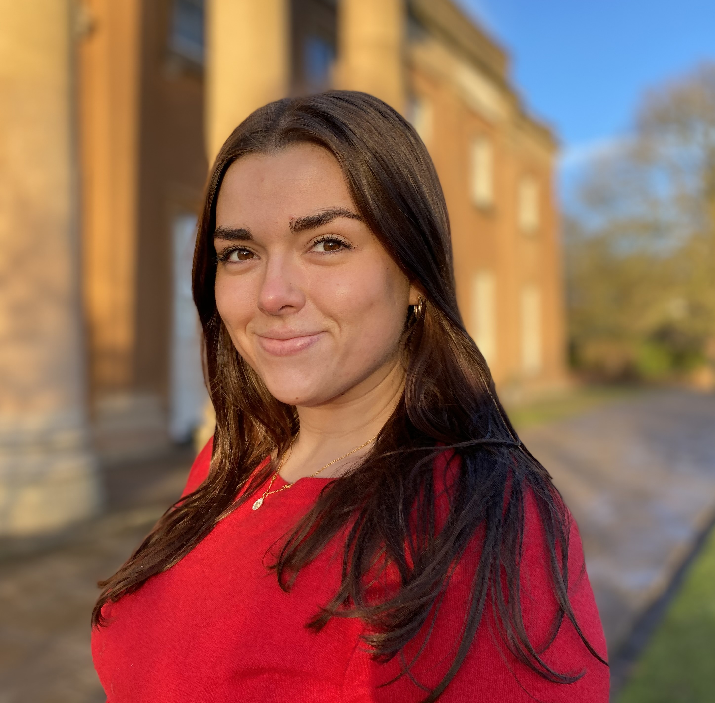 |  | Alice Spilman  Postdoctoral Fellow  Alice Spilman is a Ph.D. candidate at the University of Birmingham and a Policy Fellow at the British American Security Information Council (BASIC). Her thesis research focuses on normative ideas and discourse around nuclear weapons, and in particular looks at the concept of nuclear responsibility. At BASIC, Alice has been a part of the Programme on Nuclear Responsibilities since 2019. She has co-facilitated a number of Track 2 and Track 1.5 dialogues and co-authored the recently published Nuclear Responsibilities Toolkit. Alice is also currently co-deputy director of International Student Young Pugwash, and a m of the inaugural P5 Young Professionals Network representing the UK.
 |  | Gabriela Maria Maier Tolic  Master’s Student  Gabriela Maria Maier Tolic is a graduate student in the Master of International Relations program at Charles University in Prague. In her final thesis, she is researching the legal status of nuclear weapons under international law. As a dual citizen of Croatia and Germany, Maier Tolic's interest in finding solutions for global problems has always been strong. Currently, Maier Tolic is interning at two nuclear disarmament nonprofit organizations which focus on youth engagement and political activism. She also holds a B.A. in business administration with a focus on service management which she pursued in a corporate program while working at IBM.
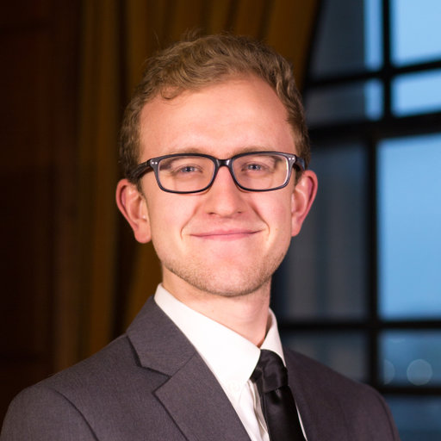 |  | Alex Vazsonyi  Physicist  Alex Vazsonyi earned his B.S. in Mechanical Engineering at the University of Kentucky and his M.S./Ph.D. in Aerospace Engineering from the University of Michigan. There, his research focused on computational gas and plasma dynamics relevant to electric propulsion for spacecraft. Outside of his graduate research, he was an elected Representative on the Rackham Student Government’s Physical Sciences and Engineering Division. Further, he served as Vice Chair of Student Advocates for Graduate Education, a coalition of graduate students who engage in federal level advocacy on behalf of graduate students at public R1 institutions nationwide. Upon graduating, he joined Lawrence Livermore National Laboratory as a Physicist in July 2021, and has since gained an interest in becoming better versed and more involved in the policy surrounding the field of nuclear weapons. In his free time, Alex enjoys chasing his cat around the house, whispering to his plants in the garden, camping, and video gaming, among other things.
 |  | Spenser A. Warren  Ph.D. Candidate  Spenser A. Warren is a Ph.D. Candidate studying Political Science at Indiana University Bloomington. His broader research interests include nuclear politics and strategy, Russian foreign policy, great power competition, and European and Eurasian security. His dissertation project examines the factors driving Russian nuclear modernization. His work has been published or is forthcoming in Asia Survey and the Oxford Handbook Series.
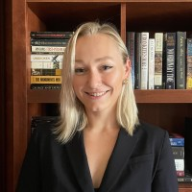 |  | Jamie Withorne  Research Assistant  Jamie Withorne is a graduate affiliate and research assistant with the Oslo Nuclear Project at the University of Oslo. She is pursuing her MPhil in Peace and Conflict Studies at the University of Oslo. With the Oslo Nuclear Project, Jamie’s work focuses on nonproliferation, verification, and open-source analysis of North Korean nuclear issues. In addition to her University of Oslo commitments, Jamie is an International Atomic Energy Agency Marie Sklodowska-Curie fellow. She is a Leader for Tomorrow with the Youth for Disarmament initiative hosted by the United Nations Office for Disarmament Affairs and the Ministry of Foreign Affairs of the Republic of Korea. Previously, Jamie worked as a Research Assistant at the James Martin Center for Nonproliferation Studies (CNS). Jamie is from South Dakota and received her B.A. in Political Science from Columbia University.

